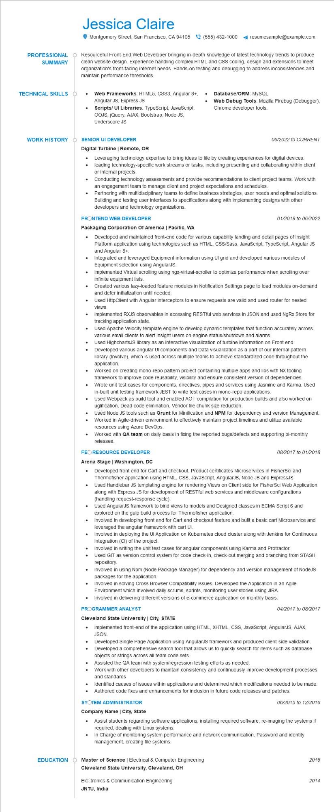
PROFESSIONAL
SUMMARY
Jessica Claire
Montgomery Street, San Francisco, CA 94105 (555) 432-1000
resumesample@example.com
Resourceful Front-End Web Developer bringing in-depth knowledge of latest technology trends to produce clean website design. Experience handling complex HTML and CSS coding, design and extensions to meet organization's front-facing internet needs. Hands-on testing and debugging to address inconsistencies and maintain performance thresholds.
TECHNICAL SKILLS
•
Web Frameworks: HTML5, CSS3, Angular 8+, Angular JS, Express JS
Scripts/ UI Libraries: TypeScript, JavaScript,
•
Database/ORM: MYSQL
Web Debug Tools: Mozilla Firebug (Debugger), Chrome developer tools.
OOJS, JQuery, AJAX, Bootstrap, Node JS, Underscore JS
WORK HISTORY SENIOR UI DEVELOPER
Digital Turbine | Remote, OR
•
•
•
06/2022 to CURRENT
Leveraging technology expertise to bring ideas to life by creating experiences for digital devices. leading technology-specific work streams or tasks, including presenting and collaborating within client or internal projects.
Conducting technology assessments and provide recommendations to client project teams. Work with an engagement team to manage client and project expectations and schedules.
Partnering with multidisciplinary teams to define business strategies, user needs and optimal solutions. Building and testing user interfaces to specifications along with implementing designs with other developers and technology organizations.
FRONTEND WEB DEVELOPER
Packaging Corporation Of America | Pacific, WA
•
•
•
01/2018 to 06/2022
Developed and maintained front-end code for various capability landing and detail pages of Insight Platform application using technologies such as HTML, CSS/Sass, JavaScript, TypeScript, Angular JS and Angular 8+.
Integrated and leveraged Equipment information using Ul grid and developed various modules of Equipment selection using AngularJS.
Implemented Virtual scrolling using ngx-virtual-scroller to optimize performance when scrolling over infinite equipment lists.
Created various lazy-loaded feature modules in Notification Settings page to load modules on-demand and defer initialization until needed.
Used HttpClient with Angular interceptors to ensure requests are valid and used router for nested views.
Implemented RXJS observables in accessing RESTful web services in JSON and used NgRx Store for tracking application state.
Used Apache Velocity template engine to develop dynamic templates that function accurately across various email clients to alert Insight users on engine status/shutdown and alarms.
Used HighchartsJS library as an interactive visualization of turbine information on Front end. Developed various angular Ul components and Data visualization as a part of our internal pattern library (Involve), which is used across multiple teams to achieve standardized code throughout the application.
Worked on creating mono-repo pattern project containing multiple apps and libs with NX tooling framework to improve code reusability, visibility and ensure consistent version of dependencies. Wrote unit test cases for components, directives, pipes and services using Jasmine and Karma. Used in-built unit testing framework JEST to write test cases in mono-repo applications.
Used Webpack as build tool and enabled AOT compilation for production builds and also worked on uglification, Dead code elimination, Vendor file chunk size reduction.
Used Node JS tools such as Grunt for Minification and NPM for dependency and version Management. Worked in Agile-driven environment to effectively maintain project timelines and utilize available resources using Azure DevOps.
Worked with QA team on daily basis in fixing the reported bugs/defects and supporting bi-monthly releases.
FEORESOURCE DEVELOPER
Arena Stage | Washington, DC
08/2017 to 01/2018
Developed front end for Cart and checkout, Product certificates Microservices in Fishersci and Thermofisher application using HTML, CSS, JavaScript, AngularJS, Node JS and ExpressJS. Used Handlebar JS templating engine for rendering Views on Client side for FisherSci Web Application along with Express JS for development of RESTful web services and middleware configurations (handling request-response cycle).
Used AngularJS framework to bind views to models and Designed classes in ECMA Script 6 and explored on the gulp build process for Thermofisher application.
Involved in developing front end for Cart and checkout feature and built a basic cart Microservice and leveraged the angular framework with cart UI
Involved in deploying the UI Application on Kubernetes cloud cluster along with Jenkins for Continuous Integration (CI) of the project.
Involved in writing the unit test cases for angular components using Karma and Protractor.
• Used GIT as version control system for code check-in, check-out merging and branching from STASH repository.
•
Involved in using Npm (Node Package Manager) for dependency and version management of NodeJS packages for the application.
Involved in solving Cross Browser Compatibility issues. Developed the Application in an Agile
Environment which involved daily scrums, sprints, monitoring user stories using JIRA.
•
Involved in delivering different versions of e-commerce application on monthly basis. PROGRAMMER ANALYST
04/2017 to 08/2017
Cleveland State University | City, STATE
•
Implemented front-end of the application using HTML, XHTML, CSS, JavaScript, AngularJS, AJAX, JSON.
•
Developed Single Page Application using AngularJS framework and produced client-side validation. Developed a comprehensive search tool that allows us to quickly search for items such as database objects or strings across all team code sets
•
Assisted the QA team with system/regression testing efforts as needed.
• Work with other developers to maintain consistency and continuously improve development processes and standards
Identified causes of issues within applications and determined which modifications needed to be made. • Authored code fixes and enhancements for inclusion in future code releases and patches.
SYOTEM ADMINISTRATOR
Company Name | City, State
06/2015 to 12/2016
Assist students regarding software applications, installing required software, re-imaging the systems if required, dealing with Linux systems.
In Charge of monitoring system performance and network communication, Password and identity management, creating file systems.
EDUCATION
Master of Science | Electrical & Computer Engineering
Cleveland State University, Cleveland, OH
Electronics & Communication Engineering
JNTU, India
2016
2014

